Dashboard and Story

Date | 08 March 2026
Team ID
Project Name | Electric Vehicle Analytics Dashboard
Maximum Marks | 4 Marks

1. Dashboard Implementation
- Design & Creativity:
Adhering to the VoltEdge Dark UI guidelines, the dashboard utilizes a high-contrast palette (Electric Blue, Slate Gray, and Neon Green) to ensure readability and a modern "high-tech" feel.
- Interactivity & Filters: To provide a dynamic user experience, the following global filters were implemented:
Brand Filter: Multi-select dropdown to compare top performers like Tesla, Tata, and Audi.
BodyStyle Filter: Allows users to segment data by SUV, Sedan, or Hatchback.
PowerTrain Filter: A critical toggle between AWD, FWD, and RWD to visualize the correlation between drivetrain and energy efficiency.
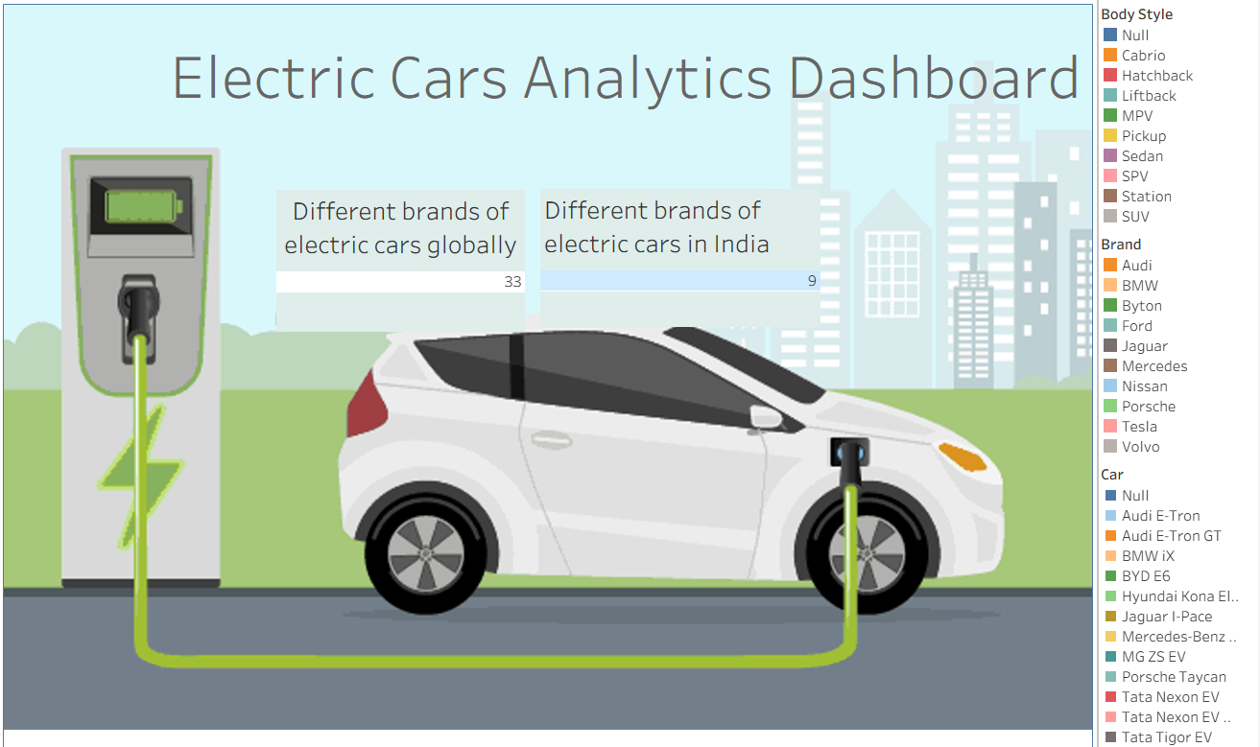

2. Storytelling (Scenes)
The Tableau Story was designed to guide different stakeholders through specific data journeys:
- Scene 1: Market Overview: A macro-view using Summary Cards and Bubble Charts, highlighting the distribution of 32 global brands compared to the emerging 9 Indian brands.
- Scene 2: Infrastructure Insight (Aarav’s Story): A geographic heatmap and stacked bar chart identifying high-demand charging zones in Noida and NDMC.
- Scene 3: Fleet Efficiency (Meera’s Story): A Treemap analysis of battery performance ($Wh/km$) vs. PowerTrain type to optimize fleet operational costs.
- Scene 4: Consumer Guide (Ravi’s Story): A "Price vs. Value" bar chart comparing the range of affordable models against premium luxury EVs.

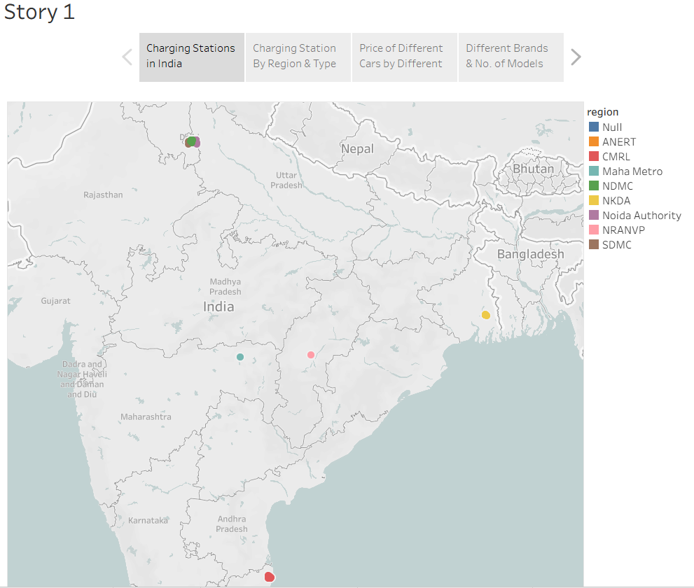
3. Web Integration (Flask)
- Publishing Strategy: The workbook was successfully published to Tableau Public. This ensures high availability and bypasses local licensing constraints, allowing the dashboard to be accessed by any web user.
- Tableau Public Links:
  - Dashboard: https://public.tableau.com/views/EVAnalysticsDashboard/Dashboard2?:language=en-US&publish=yes&:sid=&:redirect=auth&:display_count=n&:origin=viz_share_link

  - Story:
https://public.tableau.com/views/EVAnalysticsStory/Story1?:language=en-US&publish=yes&:sid=&:redirect=auth&:display_count=n&:origin=viz_share_link

- Flask Embedding: The visualizations are integrated into the VoltEdge portal using the Tableau JavaScript API (viz_v1.js). This allows the UI to render PostgreSQL-derived insights directly in the browser, providing a seamless "Single Page Application" (SPA) experience.

